Project Management Plan

1. FEASIBILITY STUDY

1.1 Technical feasibility
The required technologies are mature, free and well documented. C++17 is supported by the current GCC. SQLite requires no database server installation and no network, which matches the school’s offline requirement. The data volume is small because the system will serve about 800 students.
Concerns
- Password hashing on old hardware: Recognized libraries are deliberately slow and memory-hungry. Cost parameters must be tuned so that login stays fast on the school’s old computers. This is mitigated by the hashing spike in task 4.1.
- Concurrency: SQLite allows one writer at a time. This is fine on a single school computer; however, a multi-computer deployment would need a design decision, such as installing the system on one machine that users reach in the lab.

1.2 Operational feasibility
The users are teachers, HODs, students and an administrator, who are not IT experts. The workflow mirrors what schools already do on paper, which supports acceptance. Offline operation fits the unreliable internet. The student representative needs to be able to resubmit before the deadline and have late work accepted, so the system is expected to meet these needs by allowing resubmission until the deadline, accepting and flagging late submissions, and having the feedback field as part of each mark.
Concerns
- A console interface may feel unfriendly, and mandatory HOD moderation of every mark may slow release. This is mitigated by a short manual for each role, an installation guide that a technician can follow, and plain-language prompts before irreversible steps.
Conflict to resolve. The Principal wants no student to see a mark before moderation, while the Lecturer wants students to get marks as soon as they are marked. These can be reconciled: the lecturer sees and saves the mark at once, and the student sees it after release. This is a proposal for task 2.1, to be confirmed with the supervisor at Gate 1.

1.3 Economic feasibility
ITEM | ESTIMATED COST | ASSESSMENT
Software licences | M0.00 | C++ compilers, CMake, Git, SQLite, GoogleTest and static analysers are all free and open source.
Hardware | M0.00 | No new hardware is needed because the system targets the school’s existing old computers.
Hashing library | M0.00 | Free, with a permissive licence.
Printing the report and manuals, if required | M50.00 | This is optional.
Mobile data for downloads and submissions | M200.00 | About 7 weeks of occasional use.
Developer effort | No cash cost | About 240 hours over 7 weeks.
Running costs | Minimal | Small maintenance allowance for CR1 and a short per-role training session.
Total estimated cash cost | M250.00 | Excludes developer time.

Benefits for the school. No licence fees or server; works on existing computers; less time spent collecting marks and settling disputes about who changed a mark and when; and a clear, rule-based late penalty that is applied the same way to every student. These benefits are mainly qualitative. Before real deployment the school should estimate the staff hours saved per term, but that is outside the scope of this assignment.
Alternatives. Using an existing system would avoid development cost, but it would need a web server and a database server and would depend on a reliable network, so it would not meet the course aim of building a C++ application. Staying with paper and spreadsheets has no cost but does not enforce moderation or record mark changes. Building the system is therefore justified for this project.

1.4 Legal feasibility
Data protection. The system stores learners’ names, course enrollments, submissions, marks and feedback. Most learners at a secondary school are under 18, so this is personal data about children and needs extra care. In Lesotho the relevant law is the Data Protection Act 2011. In practice the principles the design must follow are: collect only the data needed, use it only for the stated school purpose, keep it accurate, keep it secure, keep it no longer than needed, and let people see and correct their data. The design therefore uses role-based access so that users see only what they should, keeps an audit log of every mark change, and relies on the school, as the data controller, to handle notices and consents.
Licensing. The chosen libraries use permissive licenses, and static analysers are used as tools only.
Academic rules. The work is individual. Any external code, diagrams or text must be referenced, and I must be able to explain each part in the viva.

1.5 Schedule feasibility
The project runs from 28 September 2026 to 7 November 2026. The Work Breakdown Structure allocates the following time to each phase (calendar days, from the Gantt chart):
- Planning and management: 3 days (28–30 Sep)
- Requirements engineering: 7 days (1–7 Oct)
- System design: 8 days (8–15 Oct)
- Implementation: 10 days (16–25 Oct)
- Verification and validation: 14 days (16–29 Oct, overlapping with implementation)
- Configuration management and quality assurance: 12 days (16–27 Oct, overlapping with implementation)
- Deployment: 2 days (30–31 Oct)
- Maintenance: 4 days (1–4 Nov)
- Completion: 9 days (30 Oct–7 Nov)
The Gantt chart has 26 rows including milestones. The planned finish for the last task is 6 November, so there is a one-day buffer before the submission date of 7 November.
Concerns. The design phase is compressed to 8 days for 24 marks, which is the highest-value component, and implementation is 10 days for 21 marks. Any slip cascades.

1.6 Recommendation
The recommendation is to proceed with the system. The project is technically and legally sound, it costs almost nothing, and it meets the stakeholders’ needs if the design keeps to a simple console interface and offline SQLite storage. The schedule is tight, so the submission date must be confirmed and the work planned to finish before it. If the design is not approved by Gate 2, the scope should be reduced rather than the schedule extended.

2. WORK BREAKDOWN
STRUCTURE
4.1 CORE IMPLEMENTATION
5.VERIFICATION AND VALIDATION
4. IMPLEMENTATION
4.2 CONSOLE UI
8.MAINTENANCE
9.COMPLETION
2. REQUIREMENTS ENGINEERING
MODERATED LEARNING MANAGEMENT SYSTEM
SUBMISSION
9.2 REPORT AND VIVA PRESENTATION
9.1 PROFESSIONAL AND LEGAL ISSUES
8.3 CR1 REGRESSION TESTING
8.2 CR1 IMPLEMENTATION (RELEASE V1.1)
8.1 CR1 IMPACT ANALYSIS
7.DEPLOYMENT
RELEASE V1.0
7.1 DEPLOYMENT AND MANUALS
6.CONFIGURATION MANAGEMENT AND QUALITY ASSURANCE
6.2 QUALITY ASSURANCE
6.1 CONFIGURATION MANAGEMENT
5.3 SYSTEM TESTS AND FIXES
GATE3- VERIFICATION AND VALIDATION
5.2 AUTOMATED UNIT AND INTEGRATION TESTS
5.1 TEST STRATEGY
3. SYSTEM DESIGN
GATE2- DESIGN REVIEW
3.4 DATABASE DESIGN
3.3 BEHAVIOURAL MODELS
3.2 CLASS DIAGRAM
3.1 ARCHITECTURE
GATE1- REQUIREMENTS REVIEW
2.2 SRS AND USE CASE MODEL
2.1 STAKEHOLDER ANALYSIS AND CONFLICT RESOLUTION
1.2 WBS, GANTT CHART AND RISK REGISTER
1. PROJECT PLANNING AND MANAGEMENT
1.1 FEASIBILITY STUDY AND PLAN

2.1 How the work breakdown is structured
The diagram on the previous page breaks the project into three levels. Level 0 is the whole project. Level 1 is the eight phases from the brief plus the completion phase, in the same order as the Waterfall model. Level 2 is the work package or milestone in each phase. Each Level 2 box carries the same ID as its row in the Gantt chart, so every box can be found on the schedule and every schedule row can be found in the WBS.
Red boxes are critical tasks and green boxes are non-critical tasks, matching the colours of the Gantt chart. Boxes with a dashed border and a diamond are milestones: Gate 1, Gate 2, Gate 3, Release v1.0 and Submission. They take no time but mark a point that must be reached before the next work starts.
The WBS follows the 100% rule: the packages under each phase add up to all the work in that phase, and no work appears under two phases. Each package is named by what it produces, so it can be checked as done or not done.

3. GANTT CHART WITH MILESTONES AND CRITICAL PATH
The Gantt chart on the next page shows every task in the Work Breakdown Structure with its dates, predecessors, dependencies and milestones. Critical tasks are shown as red bars and non-critical tasks as green bars.

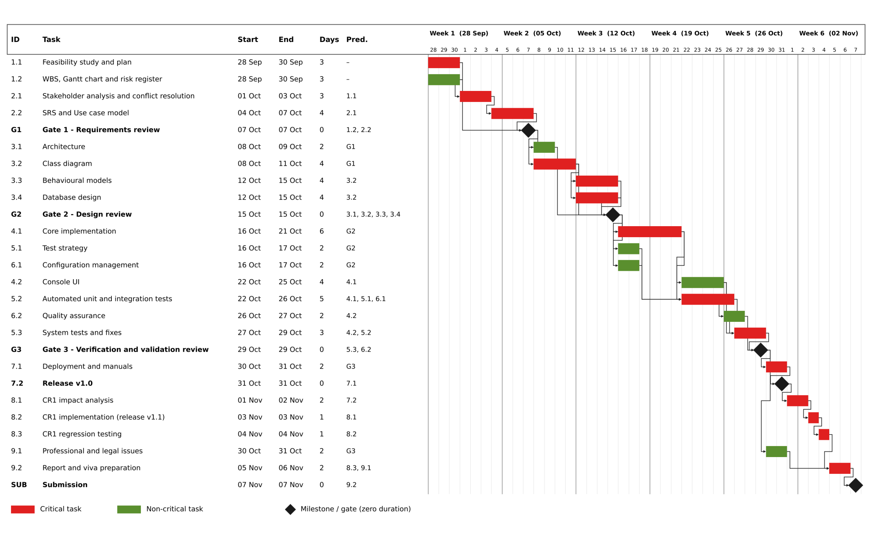

3.1 The critical path
The critical path is the longest chain of dependent tasks. From the Gantt chart it is:
1.1 → 2.1 → 2.2 → G1 → 3.2 → 3.3 and 3.4 → G2 → 4.1 → 5.2 → 5.3 → G3 → 7.1 → 7.2 (Release v1.0) → 8.1 → 8.2 → 8.3 → 9.2 → Submission
That is 19 of the 26 rows. The plan finishes its last task on 6 November and the submission is on 7 November, so the whole chain has one day of buffer.

3.2 Milestones
- Gate 1 – Requirements review (7 Oct): The stakeholder analysis, SRS and use case model should be complete before passing Gate 1.
- Gate 2 – Design review (15 Oct): The architecture, class diagram, behavioural models and database design should be complete before passing Gate 2. Implementation may not start before this review is done.
- Gate 3 – Verification and validation review (29 Oct): The system tests should be passed and quality assurance finished before passing Gate 3.
- Release v1.0 (31 Oct): The deployment package and manuals should be ready before the first version of the system is released.
- Submission (7 Nov): The report and the repository link should be submitted.

4. RISK MANAGEMENT
The risks were identified by walking through four sources: the stakeholder conflicts, the technologies, the single-person team structure and the schedule analysis.
Scales
Likelihood (L) and Impact (I) are each scored from 1 to 5. Exposure = L × I (Boehm, 1991), from 1 to 25.
SCORE | LIKELIHOOD | IMPACT
1 | Rare (<10%) | No effect on marks or schedule
2 | Unlikely (10–30%) | Minor
3 | Possible (30–50%) | Moderate: 2–3 days of rework or one component weakened
4 | Likely (50–80%) | Major: a phase delayed or significant mark loss
5 | Almost certain (>80%) | Severe: a gate or the whole submission at risk

EXPOSURE | RATING | RESPONSE RULE
20–25 | Critical | Act at once and report to the supervisor
12–19 | High | Mitigation in place and checked weekly
6–11 | Medium | Mitigation planned and checked at each gate
1–5 | Low | Accept and monitor

4.1 Risk register
ID | CATEGORY | RISK | LIKELIHOOD | IMPACT | EXPOSURE | MITIGATION | OWNER
R1 | Project | Schedule overrun: The plan has one day of buffer and 19 of 26 Gantt rows are critical, so any slip on the critical path moves the submission date. | 4 | 5 | 20 (Critical) | Track progress against the Gantt chart every Friday. Keep the buffer unused and start each phase on its planned date. | Developer
R2 | Project | Conflicting or changing requirements: The Principal and the Lecturer disagree on when students see marks, and the HOD late-penalty rule can be read more than one way. Any unresolved conflict will cause rework in design. | 3 | 4 | 12 (High) | Write each conflict and its resolution in the stakeholder analysis. Get the supervisor to confirm the penalty rule with worked examples. | Developer / Supervisor
R3 | Project | Inconsistent diagrams: The code, class diagrams, ERD and tests drift apart, and marks are lost as stated in the brief. | 3 | 4 | 12 (High) | Use one checklist per gate: names in diagrams must equal names in code and SQL. Update the diagram in the same commit as any design change. | Developer
R4 | Technical | Core implementation is underestimated: It is 6 working days for all Must requirements, role-based access and password hashing. | 4 | 4 | 16 (High) | Use the console UI only, which the brief allows. Reuse one generic repository class for the SQLite tables. Finish the design with classes already mapped to tables. | Developer
R5 | Technical | Weak security implementation: Wrong use of the hashing library, or plain-text passwords stored by mistake. | 3 | 4 | 12 (High) | Write security tests, use a recognised library and run cppcheck in CI. | Developer
R6 | Technical | Data loss: A corrupt SQLite file or an accidental delete destroys code or the report. | 2 | 5 | 10 (Medium) | Keep the database on the local disk of one machine. Keep a second copy of the report and diagrams on a USB drive or cloud folder. | Developer / IT officer
R7 | People | Developer unavailable due to illness or exam demands: This is a one-person project, so there is no one to cover for lost days. | 2 | 5 | 10 (Medium) | Plan work in 2-day blocks so that nothing depends on one long session. Tell the supervisor early if more than 2 days are lost. | Developer
R8 | People | Delayed supervisor feedback at gates: This holds up the next phase because implementation may not start before Gate 2. | 2 | 3 | 6 (Medium) | Continue with tasks that do not depend on gate reviews. Book the gate reviews in the first week. | Supervisor

4.2 Updating the register at each phase gate
The register will be reviewed at Gate 1 (7 October), Gate 2 (15 October) and Gate 3 (29 October), and the updated register will be included in the appendices of the final report. At every gate I will:
- Re-score the risks after conflict resolution.
- Close retired risks and record the issues that occurred and the mitigation outcomes.
- Add new risks found in the phase just completed.
- Add design-stage risks.

REFERENCES
Boehm, B.W. (1991) ‘Software risk management: principles and practices’, IEEE Software, 8(1), pp. 32–41.
Government of Lesotho (2011) Data Protection Act 2011. Maseru: Government of Lesotho.

